OOPD Assignment

BPO Management System

Ayush Kumar

202017B3622

Contents

Problem Statement 2

Solution 2

Program description 2

Use Case Diagram 3

Sequence Diagram 4

Class Diagrams 5

# Problem Statement

With the reduction in communication costs and improved bandwidths and associated infrastructure, BPO as a segment is witnessing a massive growth. One of the key challenges that BPO companies that provide data entry/data validation services is an efficient and effective way of getting the source documents from different customers and accurately route the same to different operators for processing. The customer has to register to get the service from BPO systems.

# Solution

## Program description

The BPO Management system project is a Java-based application that operates on the console. The project follows programming best practices, making use of Object-Oriented Programming (OOP) concepts, modular design, and adhering to coding standards to ensure readability and maintainability of the codebase.

The system has two types of users: Client and BPO Manager. A client is an organization that provides services, while a BPO Manager is an organization that requires specific services. Both types of users can register as new users, with their details stored in the system's database.

The system incorporates a simulated OTP verification system to reset forgotten passwords. The system's login feature is available to both user types, granting them access to their respective portals, the Client portal, and the BPO Manager Portal.

The system implements a feature that restricts clients from performing any work actions until they are assigned a BPO Manager. Once assigned, clients can view and complete tasks assigned to them. They can also view their own account details and change their password using their old password for verification. The client user can delete their account only if there is no active contract with a BPO Manager.

BPO Managers can view all their client contracts and create new contracts with clients that are not already in a contract. They can also terminate a contract with their own clients. Additionally, BPO Managers can create new tasks and assign them to clients, view all tasks that their clients have, and view their own account details.

The application provides an easy-to-use interface for both user types to log in, log out, and exit the application. The system's design and implementation adhere to programming best practices, ensuring efficient performance, and scalability of the application.

## Use Case Diagram

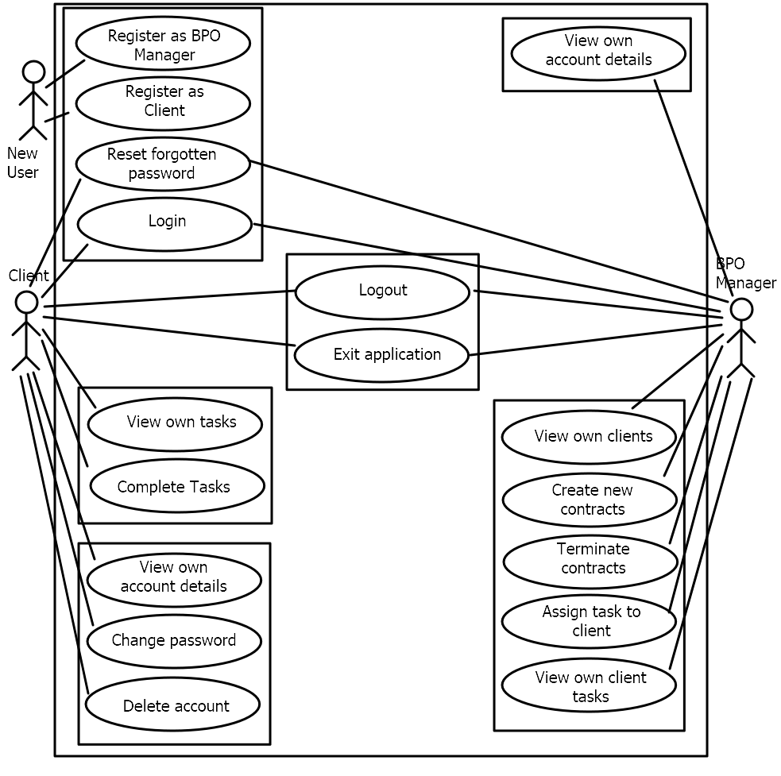

## Sequence Diagram

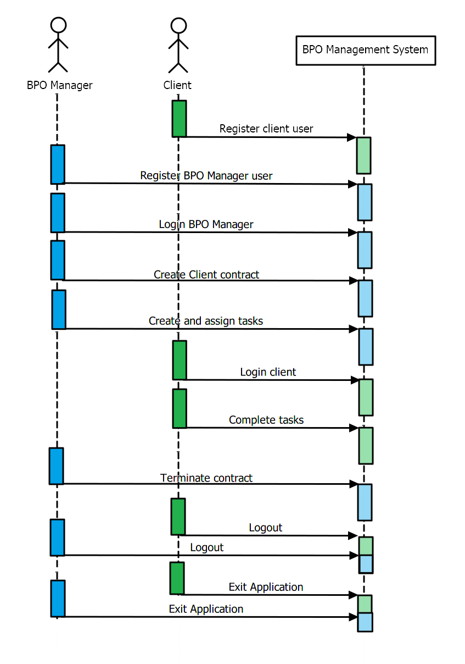

## Class Diagrams

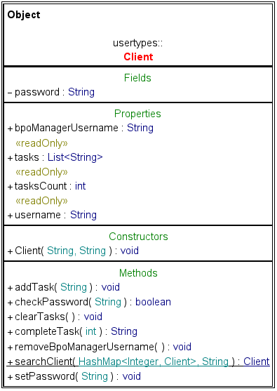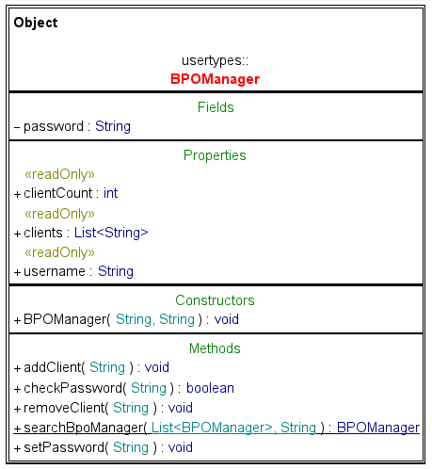

## How to execute the program?

1. Open a command prompt window.
2. Navigate to the project directory containing *BPOProject.jar.*
3. Run the jar file using the command *java -jar BPOProject.jar.*
4. If you face the following error:

*Error: LinkageError occurred while loading main class App java.lang.UnsupportedClassVersionError: Preview features are not enabled for App (class file version 63.65535). Try running with '--enable-preview'*

Run with the following command:

*Java --enable-preview -jar BPOProject.jar*